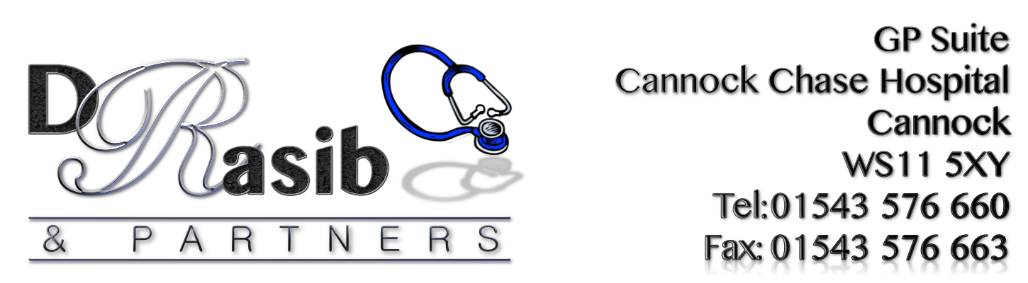
RESULTS FOR PATIENT SURVEY 2017

76% stated that they were aware that they can pre-book appointments – No action required

63% of patients stated that they were aware of the practice triage system. However 35% of patients are still not aware of this so this needs to be advertised further so that patients can benefit from this where needed especially in the event that they need access to advice from a clinician when no appointments are available. This item is to be included on the Action Plan.

The results highlighted that 86% of patients agreed when it came to information being shared with NHS departments and services - No action required

84% of patients stated that they found their overall experience of the surgery to either be excellent, good or fair. Staff will be informed to continue to provide a high level of service at all times– No action required

79% of patients stated that they would recommend the GP Practice to someone just moved to the area - No action required

30% of patients stated that getting through on the phone was poor. The practice is aware that getting through on the phones has been an on-going problem and is working with the hospital to try and introduce a new phone system. This item is to be included on the Action Plan.

30% of patients surveyed stated that the ability to speak to a doctor on the phone when they had a question or need to seek medical advice was poor. This needs to show improvement. This item is to be included on the Action Plan.

45% of patients surveyed said that when they needed to see a GP urgently that they didn’t normally get seen on the same day. This item is to be included on the Action Plan.

92% of patients surveyed were happy with the service provided by the receptionists, this shows to be the same as last year and the team will be asked to continue to provide a high level of customer service at all times – No action required.

83% of patients surveyed told us that they felt that the GP involved them in decisions about their care– No action required.

87% of patients surveyed told us that they felt that the Nurse involved them in decisions about their care– No action required.

58% of patients said that they weren’t aware about some of the services offered by the practice. The Practice will continue to raise awareness about these services with the help of the PPG group. This item is to be included on the Action Plan.

GENERAL COMMENTS RECEIVED:
GOOD POINTS:
- First Class Care
- I have always received “First Class Care” from Dr Rasib
- Staff are friendly & helpful
- Caring people
- Overall good practice & service
- Tends to be short waiting times – appointments rarely run late
- I’ve been very happy. Receptions staff help & professional.
- Receptionists are really nice, Doctors & nurse I see are very good, Wouldn’t have a thing wrong to say
- Can generally get seen pretty quickly and my children get seen very promptly
- Getting the best care I need
- All areas have been handled with care
- Very efficient all round
- The care I have received has been very good
- Everyone is friendly
- Got appointment on same as needed, had no bad experience at this doctors
- Nice Staff
- I think it is nice to know that I can get help
- I suffer from high BP. My care is very good, I can’t complain the service is very good
- The staff good and look after the patients
- Very Caring
- We are treated as fellow human beings not as mere patients or numbers!
- We find this a welcoming caring surgery
- The appointment system has changed for the better
- Can be seen on the same day. Happy with overall service
- Brilliant doctors and nurses
- I get seen the same day
- Dr always listen and put care around your needs
- Excellent
- I can always see a doctor when I need one, keep going
- All of the members of staff are very approachable and I don’t feel intimidated
- I could ask for any better service from my GP
- I find that all members of my GPs staff are very helpful
- Have been with this doctor for 10 years and have never had a complaint. Always been treated with respect and fairly
- Always happy to help. Very good practice who have helped me with very difficult time
- Every time I have needed an apt. I always get one. No complaints
- Knowing you can talk to someone if you have a problem
- Everything really good
- Good appointment service
- Get seen fairly quickly
- Any problems are dealt with swiftly, I am satisfied with all services provided at this surgery
- GP listens and discusses my treatment, and if asked he will go out of his way to help ease my pain
- The GPs listen to you and acts upon any concerns. GPs are very pleasant this is why I remain with the GP surgery
- Can normally get an appointment same day
- Generally good, much better than previous GP
- Reception staff are friendly and always willing to help no matter what age the person is
- Involvement of care
- Breastfeeding friendly, surgery is supportive
- Doctors, nurses do a great job taking care of patients
- Good communication, listening, prompt action. Well done considering pressures in NHS
- I can always get my 9 month old an appointment when needed
- I like the way practice run, we travel from Burntwood
- Good practice that appears to care for patients + spends time with patient. Surgery is much better now thank you
- Normally if important can get appointment on day
- The overall standard is excellent
- Always answer phone fast, reception always very helpful, fast booking in. Excellent service
- Hearing Aid service option service
- Very good at helping me with my youngest son who has autism
- Always been very happy with the service I have been given Thank you
- Speaking to GP without attending
- Overall quite happy with the care I receive at the surgery
- Excellent staff
- Understanding your needs with sincere care
- The experience I had at the GP clinic is excellent
- Staff always try to meet needs
- Appointment generally are easy to book
- Staff are always friendly & informative. Dr’s explain medical issues so as to understand in ‘simpler’ terms
- Far better then other surgeries
- Excellent practice

BAD POINTS:
- Parking
- Wait time for appointments
- Getting through on the phone – very difficult in the morning
- Parking very poor
- Availability to getting an appointment earlier, although on most occasions I have no problem
- Maybe put in a call waiting service to queue up people calling
- Seats uncomfortable and surgery is always too hot
- I do not feel I should have to give details to receptionists
- More phone lines, see the GP on the same day you ring
- A bleep/ping when name comes up on board
- No children’s toys or books anymore
- Toys for children and more phone lines
- Parking is a nightmare, this is the only reason I would not recommend the practice to anyone new to the area
- A water machine for patients waiting to be seen, more entertainment for children, toys or books
- Maybe have telephone appointments like other surgeries – possibly free up time?
- How about an early surgery one day a week for working people or late in evening
- Ability to book appointments needs to be improved, same day booking should stop, should be able to pre-book
- Parking always an issue for non-disabled elderly patients
- Problems getting through on the phone
- Don’t like the fact that we have to discuss our illness with the receptionist when we call for an appointment
- Phone improvement
- Parking
- Waiting room always too hot
- Being able to pre-book appointments
- When calling can hardly get same day appointment
- Don’t agree with giving personal information on the phone, shouldn’t have to tell receptionists my reason to see GP
- Telephone needs extra lines
- Parking for patients
- More appointments available to be booked on line
- Name on screen no audio alert
- When your name comes up for appointment on the screen, no audio alert to quick going across the screen
- Parking. TV adverts need to be slower so you can read them, sometimes hard to get apt.

BREAKDOWN OF COMMENTS RECEIVED:

122 Positive comments received
92 Negative comments as below:
- Telephones/Appointments - 62
- Sharing Information with reception staff – 5
- GP attitude – 3
- Service Experience – 22
30 Suggestions made through comments received

